Clinical Pharmacokinetics- Immunosuppression- Spring 2014

Nicole M. Sifontis, Pharm.D.

Clinical Professor
Office: Room 135B

Phone: 215-707-4922
Email: Nicole.sifontis@temple.edu
Office hours: Mondays 2:00 - 3:00 PM
Thursdays 12:00 - 2:00 PM or by appointment

Educational Outcomes:

After attending this lecture and working through the cases in class, the student should be able to:

- Describe the pharmacokinetic and pharmacodynamic properties of critically dosed immunosuppressants, specifically, cyclosporine (renal → Scr, electrolytes), tacrolimus and sirolimus and everolimus
Cyclosporine: renal → Scr, electrolyets, CYP3A4
Tacrolimus: CYP3A4
Sirolimus: CYP3A4
Everolimus: CYP3A4

- Given a patient case, students should be able to recommend an appropriate therapeutic plan including dose, dose adjustments and monitoring parameters for these agents
- Given a patient case, students should be able to identify and manage potential drug/ drug and drug/ food interactions

- When do we implement therapeutic drug monitoring (TDM)?
- Critically-dosed agents
  - Agents with narrow therapeutic index (NTI) ratio
  - Large inter/ intra-patient variability
  - Steep dose response relationship for either efficacy or toxicity
- Goal
  - Optimize drug therapy for individual patients

- Approaches to assess appropriateness of a dosing regimen for an immunosuppressive agent
- Clinical observation
- Assessment of pharmacokinetic (PK) properties of the drug and relate those parameters i.e. trough levels (C0) → measure at Css and AUC to efficacy and toxicity
- Use of pharmacodynamic (PD) properties to measure biologic response to a drug
- Review
- Pharmacokinetic parameters
  - A - Graph → tmax, Cmax, F
  - D - Vd
  - M - enzymes/transporters
  - E – CL, t1/2

- Pharmacodynamic parameters
  - Effect of drug measured at the site of action

- Therapeutic Drug Monitoring for CSA and TAC
 | CSA | TAC
F | 5-70%; mean 30%  IV:PO = 1:3 | 5-67%; mean 27%  IV:PO = 1:3
Tmax | 2-4 hrs | 2-4 hrs
Vd | 3-7L/kg | 5-6L/kg
Metabolism | Hepatic and intestinal CYP3A4 and transported by P-gp (responsible for inter and intra patient variability) | Same
Renal elimination | Minimal | Minimal
Half-life (t1/2) | 12-16hrs | 3.4-40.5 hrs; mean=12hrs
Strategies for monitoring | Predose trough blood concentration (C0) OR  Single point sampling 2 hours after drug administration (C2) | Predose trough blood concentration (C0)  High correlations between C0 and AUC0-4 so C2 level not recommended
Dosing | Initial 2.5mg/kg po q12 then titrated based on steady state blood trough (C0) levels  Target trough (C0) concentrations:  - 200 - 300 ng/ml during the first 6 months post-txp in kidney and liver transplant patients  - 300 - 400 ng/ml during the first 6 months in heart and heart/ lung transplant patients  - <150ng/ml after 1 year, variable depending on type of transplant, time post transplant and concomitant meds | Initial 0.03mg/kg po q12 then titrated based on steady state blood trough (C0) levels  Target trough (C0) level:  - 5-15ng/ml depending on time post transplant, transplant type and organ transplanted
 | CSA | TAC
Monitoring | 3 times/week initially and after any dose change until therapeutic level is reached.  Once stabilized, monthly or every 3 month monitoring is appropriate | Same
Dose adjustment | 25-50mg po q12 then recheck level in 2-3 days, dose adjust to achieve therapeutic level | 1-2mg po q12 then recheck level in 2-3 days, dose adjust to achieve therapeutic level

- Managing Drug Interactions
- Clinical Implications for TDM
- Maximize efficacy
- Minimize toxicity
- Manage potential drug interactions

- How can we anticipate drug interactions
- Pharmacokinetic interactions
- CYP3A4
- Most abundant and pharmacologically active enzyme present in human liver (30%) and small intestine (70%)
- Great inter/ intrapatient variability

- P-gp
- Transport protein present in the brush border on the apical surface of the enterocytes, which function to pump lipophilic substrates back into the intestinal lumen against their concentration gradient
- Remarkable overlap between inhibitors and substrates of CYP3A4 and P-gp
- P-gp pumps drug from enetercoyte in intestine, back into the intestine → lower serum levels

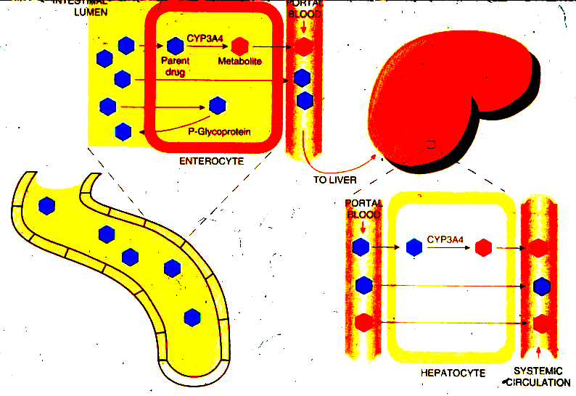
- Food and Drug Interactions with CSA and TAC

- Drugs that ↓ CSA/ TAC levels (CYP3A4/ P-gp inducers)
- Phenytoin
- Phenobarb
- Rifampin
- Carbamazepine

- Drugs that ↑ CSA/ TAC levels (CYP3A4/ P-gp inhibitors)
- macrolides
- non-dihydropyridine CCB
- Azole antifungals
- Protease inhibitors

- Other important drug interactions…..STATINS
- Select statins are CYP3A4 substrates
- CSA is a substrate and inhibitor of CYP3A4
- Potential to increase statin concentrations with concomitant use of select statins and CSA or TAC (CSA>TAC)
- Which of the statins is the safest to use in transplant patients?

- Statin-induced myositis
- Dose-dependent reduction of vascular smooth-muscle cell proliferation
- Statins can cause release of myoglobin from breakdown of muscle cells
- Myoglobin causes renal injury or failure

Common signs & symptoms
- Muscle pain, weakness, dark urine
- Myalgia → myopathy → rhabdomyolysis
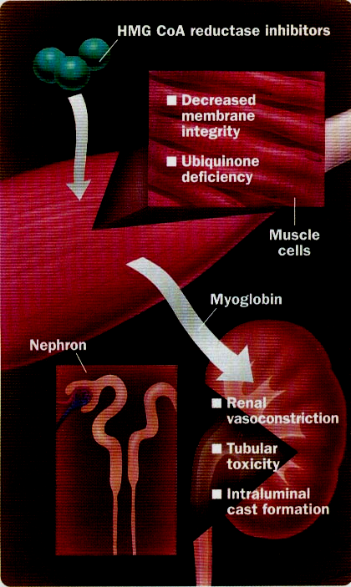

- Food/ Beverage Interaction…..Grapefruit juice (GFJ)
- Inhibit P-gp and CYP3A4 in the gut
- ↑Cmax and AUC; no change in Cl or t ½
- ↑C0 concentrations by 77%
Result………. CSA/ TAC drug concentrations

- Herbal drug interaction……St John’s Wort (SJW)
- Induce intestinal/ hepatic CYP3A4; CSA/ TAC metabolism
- Induce P-gp in gut; ↓ drug absorption → ↓ bioavailability (70%)

Result……….↓ CSA/ TAC drug concentrations

- Pharmacodynamic Interactions

- CSA/ TAC highly nephrotoxic
- Increased risk of nephrotoxicity
  - Aminoglycoside
  - Amphotericin
  - Vanco
  - NSAIDS

- Consequences of altered CSA/ TAC concentrations

- Supratherapeutic levels
- Nephrotoxicity
- Over-immunosuppression--- risk of infections
- Hypertension
- Tremors- specifically TAC
- Electrolyte abnormalities-K, ↓Mag, ↓Phos

- Subtherapeutic levels
- Transplant rejection

- Managing Drug interactions

- Rule of thumb for enzyme inhibitors:
- Monitor CSA/ TAC trough levels 2-3 days after drug initiation and adjust dose appropriately

- Rule of thumb for enzyme inducers:
- Prospectively CSA/ TAC daily dose by 25%
- Monitor CSA/ TAC trough levels 4-7 days after drug initiation and adjust dose appropriately

- Ceiling statin dose

- Limit nephrotoxic agents

Case Study

- RL is a 55 y/o, 83 kg female with ESRD 2° to HTN. The patient is scheduled to receive a living unrelated renal transplant today from her husband. The transplant team would like to implement triple immunosuppression per protocol consisting of cyclosporine, mycophenolate mofetil and prednisone. What initial dose of cyclosporine (round to nearest 25 mg) would you recommend for this patient?

RL is discharged from the hospital 5 days post-transplant, her Scr has fallen from 8mg/dl to 1.5mg/dl over the past 5 days. She returns 3 days later for a f/u visit. Her trough cyclosporine level today is 165 ng/ml (goal 200-250ng/ml). What are 2 key questions you should ask the patient prior to making any dosage changes?

How would you adjust her dose if you deem it necessary?

- A 54 year old male received a liver transplant for treatment of HCV cirrhosis 9 months ago. His post-transplant course was uneventful until today when he was diagnosed with peritoneal tuberculosis. Currently, his medications include tacrolimus 4 mg po q 12 and mycophenolate mofetil 1000 mg po bid. Tacrolimus blood levels are being maintained in the range of 5-8 ng/ml. Today’s level is 5.2 ng/ml. Liver function tests are wnl. A decision is made to initiate antitubercular therapy with ethambutol, isoniazid, rifampin and pyrazinamide.

a. What assessment can you make regarding this patient’s overall drug regimen? Be specific. Include your rationale.

b. Provide a therapeutic plan for this patient, including immunosuppression dose recommendations and specific monitoring parameters, as appropriate.

- Therapeutic Drug Monitoring for SRL/ ERL

 | SRL | ERL | Comments
F | 15% | 30% | Significantly lower than CSA and TAC
Tmax | 1.42 ± 1.2 hours | 1-2 hrs | Similar to CSA and TAC
Vd | 5.6-16.7L/kg | 2-8.4L/kg | Similar to CSA and TAC
Metabolism | Hepatic and intestinal CYP3A4 and transported by P-gp (responsible for inter and intra patient variability) | Hepatic and intestinal CYP3A4 and transported by P-gp (responsible for inter and intra patient variability) | Similar to CSA and TAC
Renal elimination | Minimal | Minimal | Similar to CSA and TAC
Half-life (t1/2) | 57-63hrs (60 hours) | 30 ± 11h
Strategies for monitoring | Predose trough blood concentration (C0) | Predose trough blood concentration (C0) | Similar to TAC
Dosing | LD= 3x MD  6mg po load then 2mg po daily  Target trough (C0) concentrations:  - 5-10ng/ml when used with a CNI | No loading dose  MD= 0.75mg po q12  Target trough (C0) concentrations:  3-8ng/ml
Monitoring | Weekly for the first month then once stable every 3 months  Adjust dose by 1-2 mg then check level in 1 week and re-adjust as necessary | Check levels every 4-5 days

- Food and Drug Interactions with SRL (SAME AS CSA/TAC)

- Consequences of altered CSA/ TAC concentrations
- Supratherapeutic levels
- Over-immunosuppression--- risk of infections
- Bone marrow suppression: anemia, leucopenia, thrombocytopenia

- Subtherapeutic levels
- Transplant rejection

- Managing Drug interactions
- SRL: No absolute guidelines on when to monitor levels due to long half life of SRL

- ERL: same as CSA/TAC

- Pharmacist’s Issues
- Be familiar with the therapeutic range for each immunosuppressive agent at your institution
- Be able to adjust medications when subtherapeutic and supratherapeutic drug levels are identified
- Always remember to assess levels in relation to when the agent was taken and be aware of drug interactions

